Game diary 2: *Cats & Soup*

Rover Vos

## Diary entry one 20th of August 2022

Dear game diary, today(I travelled to the Netherlands and played *Cats & Soup(HIDEA 2021)*. Before I even understood what the game was about a pop-up. Within 2 minutes of playing the shop opened up (*Figure 2*). I didn’t have to do anything, it just showed me what it was about(Not that I understood what everything was for). As I got into the game a little bit I figured out that It’s a game about cats making soup which you can then sell for gold. But before I understood that the game is about selling soup, the game asked me if I wanted to watch an advertisement(ad) to double my cooking speed. So I watch a 30-second ad to get a nice start to the game. With my newfound double speed, I did some cooking, sold some soup, made some money and bought some new cooking facilities. Things like carrot chopping, lettuce chopping, bouncy hammock and other things. After making/upgrading a couple of facilities the game gave me a new pop-up. I got introduced to the “*Good Luck Jar*”(*Figure 3*) a facility which sometimes gives you a pop-up so that you can watch an ad and get a bunch of gold. So I watch a 30-second ad get a boatload of currency and spend all of them for some upgrades. After doing some upgrading a new pop-up. “You can build the Treasure chest now!” (*Figure 4*) Or something along those lines. A loot box containing equipment for your cats. This equipment increases their cooking speed. The chest can be opened by watching an ad which is both time-gated and limited per day or by spending 300 gems. This treasure chest and the rest of the game are an Embedded-Isolated system(*Nielsen and Grabarczyk, 2019*).

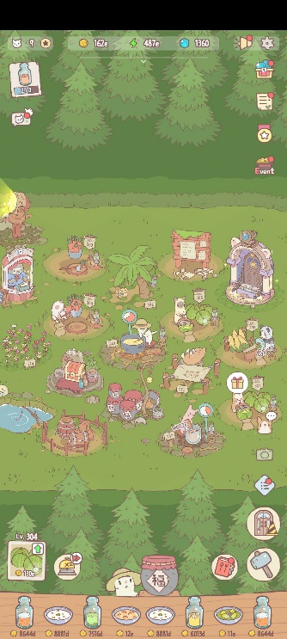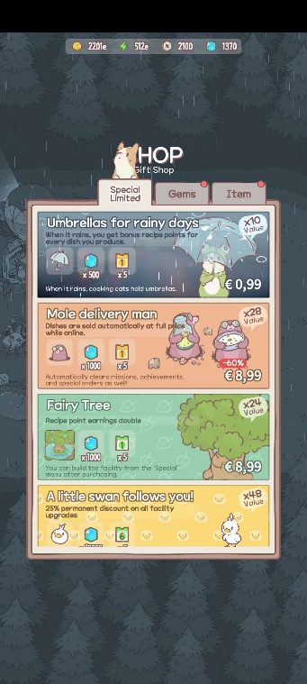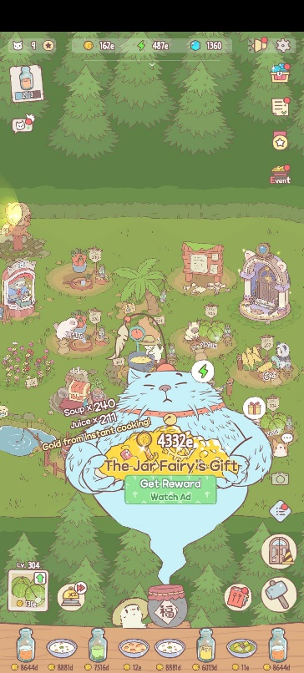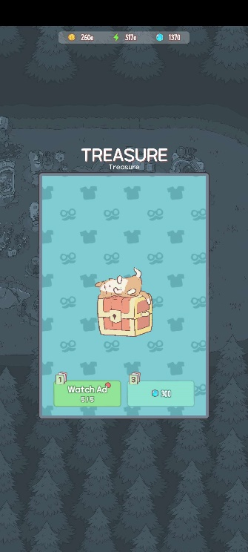

Figure Cats & Soup Figure In-game Shop Figure Good Luck Jar Figure Treasure

*All screenshots were taken on 11/01/2023*

## Diary entry two 28th of August 2022

Dear diary, in the last couple of days I have played Cats & Soup. As it’s an idle game I played throughout the day claiming my Good Luck Jar whenever I logged in, and claiming a bunch of gold which my cats gathered while I was offline which I then doubled by watching an ad. I was also introduced to the Ad Manager Office which gives me one ad skip per day. Can be upgraded with money. Also a bunch of other systems. Fishing, the Observatory, Recipes, the Christmas event, the screenshot cat and a bunch more. There are so many different systems and thus I won’t be going over all these different systems.

I got introduced to the cosmetics of the game. There are a lot of cosmetics. Each cat that cooks for you has an outfit, a room, tools, name, fur etc. and you have many cats. At the moment I already have 9 cats. I did not do anything with cosmetics, because I am not interested in cosmetics and the amount of customisation was very overwhelming to me.

## Diary entry three 2nd of January 2023

Today I played Cats & Soup again. But instead of mindlessly playing the game I found that it was time to go and explore all the mechanisms(*Tucek 2022*) and menus in search of microtransactions.

### Currencies

To figure out what is and isn’t a microtransaction first I need to know which currencies are available and if I can get them by spending money. There are 4 major currencies, gold, Recipe points, Furniture Coin and Gems.

Gold is used to upgrade your facilities. You receive exponentially more gold as the game progresses and everything is exponentially more expensive as the game progresses. However, they did this in an interesting way. Instead of showing that you have 100 Billion gold, it shows that you have 1000d. The gold scales like the decimal system but instead of using kilo, mega etc. they use the letters of the alphabet. Starting with a couple of hundred gold and now I have a couple of thousand e-gold. Gold can be obtained by playing the game and being bought with gems. The amount of gold bought depends on your current level of facilities.

Recipe points are used to upgrade your recipes. Better recipes, better food, more profit. You can acquire these points by waiting. Your cats will rest and you will get the points. Recipe points can be obtained by playing the game and can be bought with gems. The amount of Recipe points bought depends on your current level of facilities.

Furniture coins are used to buy furniture, I think. After playing the game for over 10 hours I still haven’t unlocked the furniture store. Thus I have no idea what I can do with these. Furniture coin can be obtained by playing the game and can be bought with gems. The amount of Furniture coins bought doesn’t change over time.

Gems are the currency which you can buy with money and then convert to many different things. You can buy other currencies, ad skips, items etc. with gems. Gems can be obtained by playing the game by completing achievements and daily missions. You can also play mini-games to obtain gems.

### Ad Manager Office

The Ad manager Office has two upgrades. To upgrade to level one it costs €8,99 giving 5 extra daily ad skip tickets. Level two it costs €17,99 and gives another 10 extra daily ad skip tickets. Level three it costs €28,99 and gives unlimited ad skip tickets and permanent double cooking speed. All these costs are cumulative so if you want to play an ad-free game you would have to spend €55,97.

### Advertisement

Ads are a big part of the game. There are many different ways to increase loot, speed things up, get currencies etc. by watching ads. It’s interesting to note that I didn’t mind watching these ads. Normally when a game makes me watch an ad I instantly get annoyed. However, in this game, they never forced me to watch an ad. I always had the choice to watch an ad for extra value. Which is a very compelling form of ads.

### In-game shop

The in-game shop is divided into four different tabs. Seasonal Limited(*Figure 5*), Special Limited(*Figure 6*), Gems(*Figure 7*) and Item(*Figure 8*).

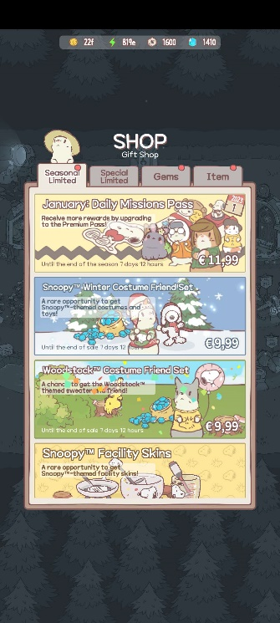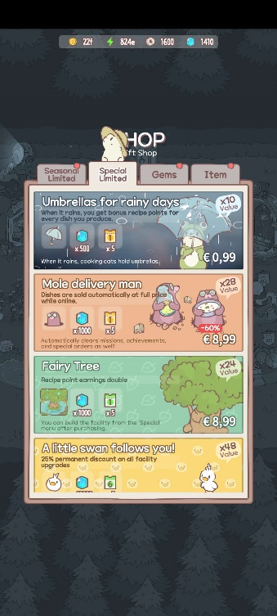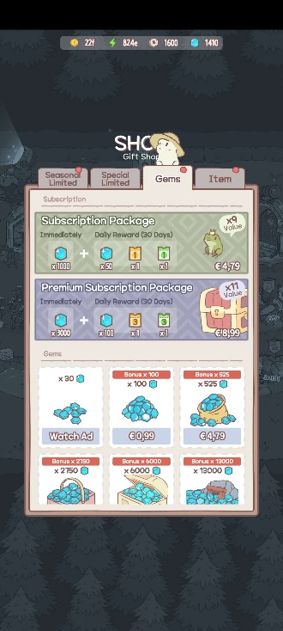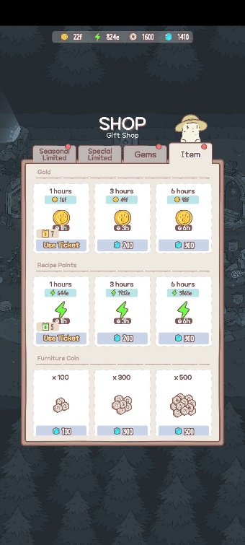

Figure Seasonal Limited Figure 6 Special Limited Figure 7 Gems Figure 8 Item

#### Seasonal Limited

Seasonal Limited has multiple different cosmetic items to buy varying between €4,99 and €11,99. There is also one option for 2000 gems. The first option in this tab is a monthly daily mission pass costing €11,99. You can buy a pass each month which gives daily mission which then gives some form of reward. You can also upgrade this pass to the premium version for another €11,99. If you would buy everything in this tab it would cost you €77,91. I think this rotates monthly.

#### Special Limited

Special Limited has various things to buy which have very good value. x12 value, x28 value or even x48 value! Whatever that means. The prices range from €0,99 all the way to €47,99 for the x48 value of course. All the purchases available give various permanent buffs for your soup-making, gems and other currencies. I think these don’t rotate and are a one-time buy. If you wish to buy everything it’s a grand total of €148,72.

#### Gems

In the gems tab, you can buy gems, but also watch an ad for 30 gems. The cheapest option is €1 for 100 gems and the most expensive option is €84,99 for 13000 gems. The gems tab also has a subscription package which gives an instant amount of gems and for the next 30 days, you get extra daily login rewards. This costs €4,79 and there is also a premium version for an additional €8,99.

#### Item

The Item tab is where you buy the other currencies with gems. See above at *Currencies* for more information.

## Diary entry four personal review 11th of January 2023

Dear diary I won’t return to Cats & Soup in fact I will delete it after finishing this diary entry. The game is just an idle game with nice art. The cats are very cute but as a player that enjoys mechanics overall other combination things Cats & Soup leaves a lot to be desired for me. I do think it’s a good idle game. The art and the progression system keep you busy for a very long time if not forever. It was very interesting to see how a game can implement a lot of different ways to watch ads and every time again you do watch it. Because why not? It’s only 30 seconds and then I get more loot.

An interesting thing I didn’t write about in my other entries is the art of the game. The art is very well done, very cute and nice to look at. I can see how people would be charmed by the art form and be wanting to come back just to watch the cats do their thing.

For my own future, if I ever decide to make a free-to-play mobile game use this form of ads. The game being 100% free to play with no forced ads is a very nice and enjoyable system.

References

HIDEA. 2021. Cats & Soup. Seoul: Neowiz

Nielsen, Rune Kristian Lundedal, and Paweł Grabarczyk. 2019. "Are Loot Boxes Gambling? Random reward mechanisms in video games." Transactions of the Digital Games Research Association 4, no. 3.

Tucek. 2022. “Session 2: Mechanics & Mechanisms”. Issues in Game Studies: Microtransactions Lecture